**MID - TERM III EXAMINATIONS, 2024**

**MIDDLE CLASS – READING**

**Name: ………………………………………………Stream: ………………..**

**1. Dictation of sounds.**

............ ........... .......... .......... .............

(10mks)

**2. Match a picture to the first sound.**

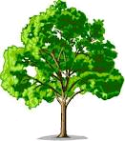

b

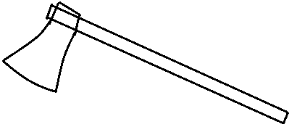

e



t

a

c

(10mks)

**3. Circle the correct word for the picture.**

pto pot

______________________________________

egg geg

______________________________________

snu sun

_______________________________________

gril girl

_________________________________________

bag gab

(10mks)

**4. Draw a picture for the given syllable.**

mu .............................. ca .............................

ba .............................. gu ............................

po ............................. (10mks)

**5. Write sounds correctly.**

.................. ..................

................. ...................

................. (10mks)

**6. Read and draw.**

pot ........................ mat .........................

tin .......................... sun ............................

bag ....................... (10mks)

**7. Name the pictures.**

........................ ..........................



 ....................... ...........................

....................... (10mks)

**(axe, ball, hut, box, cat)**

**8. Read the word and shade the picture.**

egg

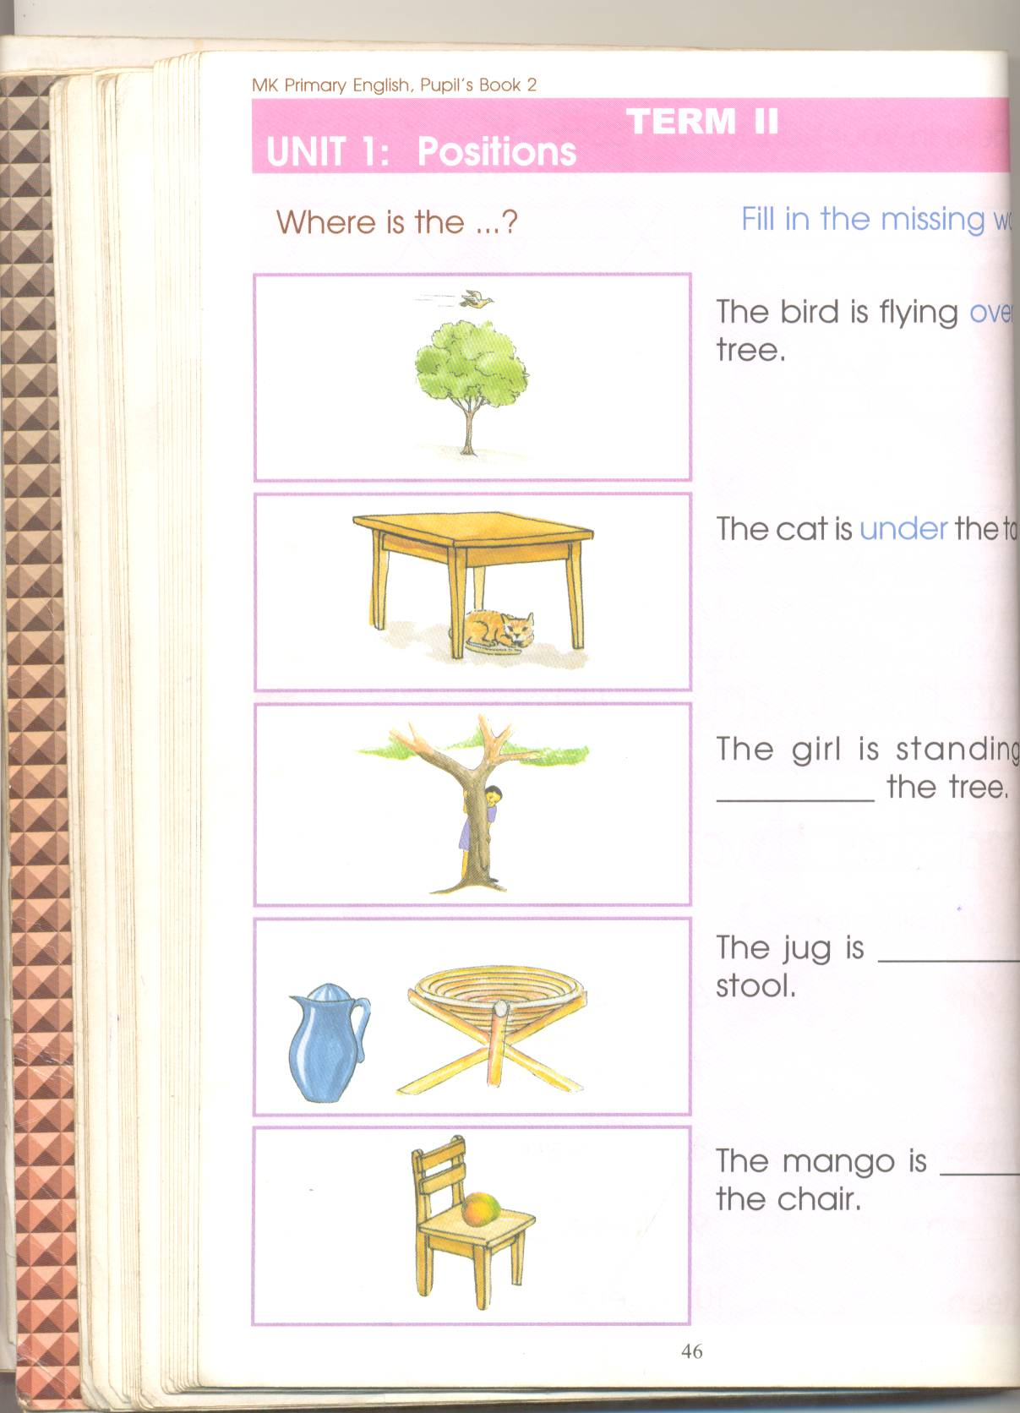 ___________________________________________

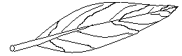 jug

 ____________________________________________

leg

 ____________________________________________

book

____________________________________________

 doll (10mks)

**9. Tick the given vowel.**

a e u

a i e i o i

o u u

i o

i e

e u o u (10mks)

**10. Match the same word and draw.**

boy doll ____________

cat bag _____________

drum cat _____________

bag drum _____________

doll boy ______________

(10mks)